# Practical 3 Write an HTML code for following table

<html>

<head> <title> </title> </head>

<body> <h3>Kaustubh Wade(160410116050)</h3>

<table border="1">

<tr>

<td colspan="2">A</td>

</tr>

<tr>

<td>B</td>

<td>C</td>

</tr>

<tr>

<td>D</td>

<td>E</td>

</tr>

</table>

</body>

</html>

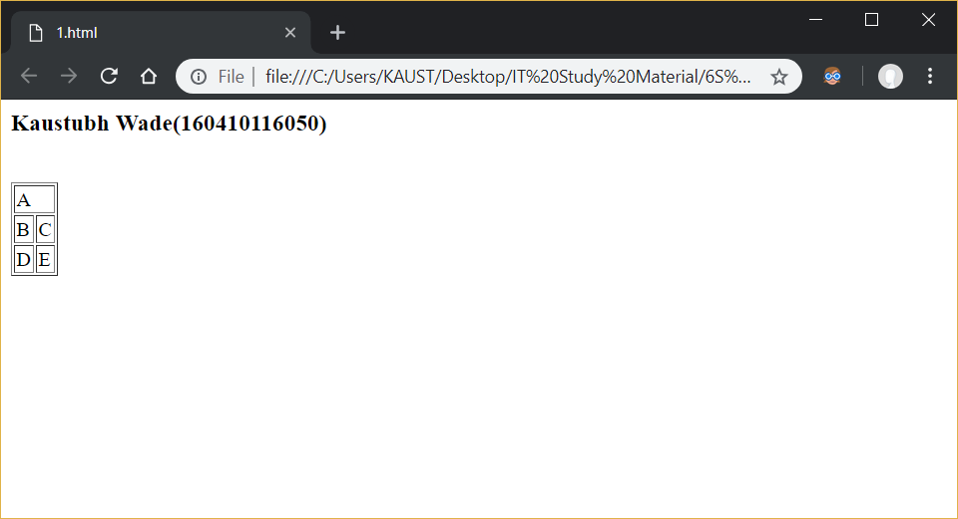

<html>

<head> <title> </title> </head>

<body>

<h3>Kaustubh Wade(160410116050)</h3>

<table border="1">

<tr>

<td rowspan="2">A</td>

<td>B</td>

<td>C</td>

</tr>

<tr>

<td>D</td>

<td>E</td>

</tr>

</table>

</body>

</html>

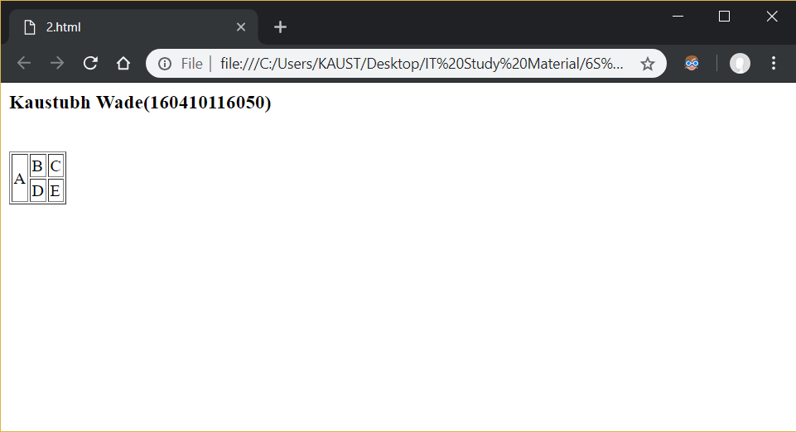

<html>

<head> <title> </title> </head>

<body> <h3>Kaustubh Wade(160410116050)</h3>

<table border="1">

<tr>

<td colspan="3">WT</td>

</tr>

<tr>

<td rowspan="2">WT</td> <td>WT</td> <td>WT</td>

</tr>

<tr>

<td>WT</td> <td>WT</td>

</tr>

<tr>

<td>WT</td> <td>WT</td> <td>WT</td>

</tr>

</table>

</body>

</html>

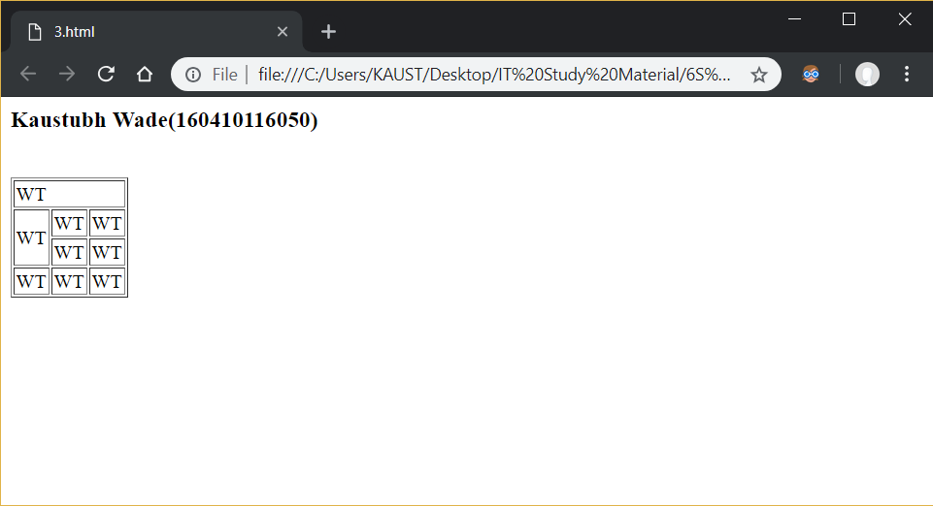

<html>

<head> <title> </title> </head>

<body> <h3>Kaustubh Wade(160410116050)</h3>

<table border="1">

<tr>

<td rowspan="2">WT</td> <td colspan="4">WT</td>

</tr>

<tr>

<td>WT</td> <td>WT</td> <td>WT</td> <td>WT</td>

</tr>

<tr>

<td>WT</td> <td>WT</td> <td>WT</td> <td>WT</td> <td>WT</td>

</tr>

<tr>

<td>WT</td> <td>WT</td> <td>WT</td> <td>WT</td> <td>WT</td>

</tr>

</table>

</body>

</html>

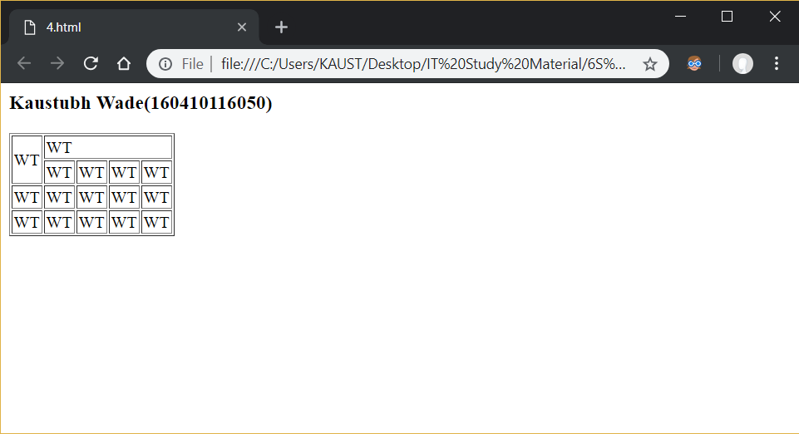

<html>

<head> <title> </title> </head>

<body>

<h3>Kaustubh Wade(160410116050)</h3>

<table border="1">

<tr>

<th colspan="4"> Work Contact Points </th>

</tr>

<tr>

<th>Name</th>

<th>Email</th>

<th>Phone</th>

<th>Floor/BLock</th>

</tr>

<tr>

<td align="center">Fred</td>

<td>fred@megacorp.com</td>

<td>123456</td>

<td align="center" rowspan="2">1A</td>

</tr>

<tr>

<td align="center">Jon</td>

<td>jon@megacorp.com</td>

<td>234567</td>

</tr>

<tr>

<td align="center">Bill</td>

<td>bill@megacorp.com</td>

<td>345678</td>

<td align="center" rowspan="3">1C</td>

</tr>

<tr>

<td align="center">Jane</td>

<td>jane@megacorp.com</td>

<td>777444</td>

</tr>

<tr>

<td align="center">Alison</td>

<td>alison@megacorp.com</td>

<td>888652</td>

</tr>

</table>

</body>

</html>

